Delivery drone:

**SOFTWARE:**

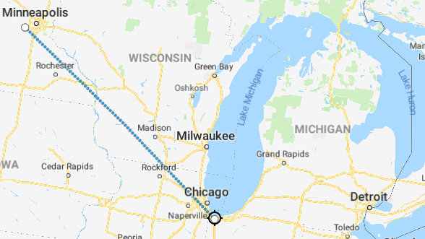

Drone delivery represents the act of moving a package from point A (departure point) to point B (destination point) using unmanned aerial vehicles (UAVs).

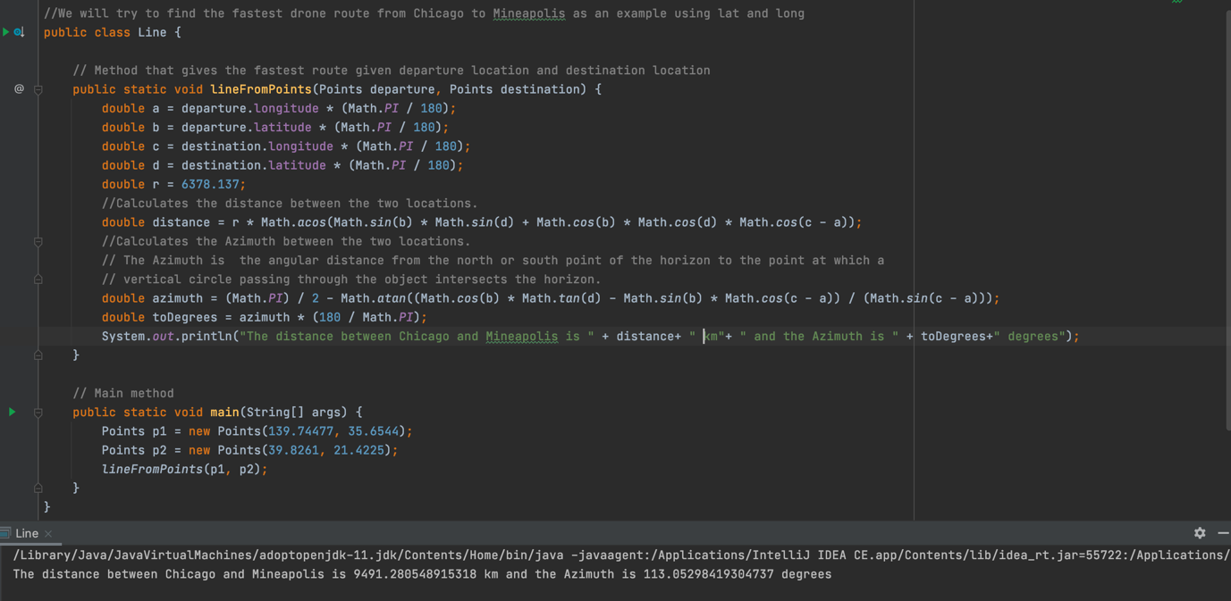

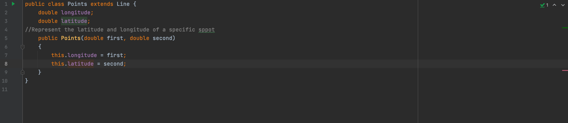

Our drone can take any two locations using AI and calculate the distance between them as well as the angular distance (Azimuth) from the north or south point. We used the example of the distance between Chicago and Minneapolis, that were later confirmed by official data.

**HARDWARE**

The infrastructure that powers drone delivery operations requires integration between reliable drone hardware and robust software. The components of such systems include: Drone Hardware, Drone Fleet Management Software (to plan and execute the trip), Onboard Drone Software (to ensure autonomous precision landing), Drone-in-a-Box Hardware (on-ground components such as a docking station, Advanced Fail-safes (Emergency Landing Point).

Persona

**SOFTWARE:**

The “Angel” team proposes thermal cameras to detect trapped humans. However, even though cameras are an efficient method to detect casualties, their effectiveness is limited by their inherent reduced angle of view and the presence of obstacles.

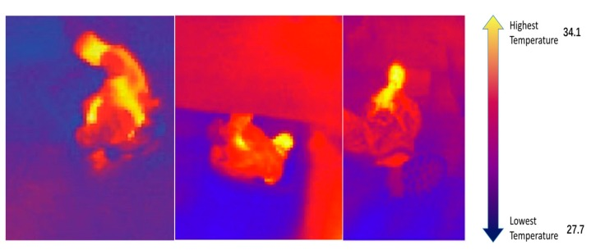

In order to optimize the efficiency of our drone, we will use a Gas sensor that can detect CO2 in a range of 350~10,000 ppm. This sensor shows excellent durability against the effects of high humidity.

